**Dynamics 365**

**Technology Specialist Environment**

Analytics & Reporting   
Demo Setup – Dataverse Data

Authored by:

**Scott Sewell**

Principal Program Manager

Fabric BI CAT (Customer Advisory Team)

Version 3.0

Contents

Introduction 2

Ensure the Power BI Extensions are updated. 2

Create Local Copies of the Report and Source Data files 3

Create a OneDrive ‘Shared Library’ 4

Import Solution containing Power BI report and dashboard. 6

Set up Power BI Credentials and Report Refresh 7

Adding the Power BI report to Dynamics 9

# Introduction

These assets are designed to help demonstrate the power of using Power BI analytics and reporting to expose the value of the data in a Dynamics 365 CE implementation.

# Ensure the Power BI Extensions are updated.

In Power Platform Admin Center, under “Dynamics 365 apps”, check to see that the “Power BI Extensions (Preview) application has been updated to at least 1.0.0.77.   
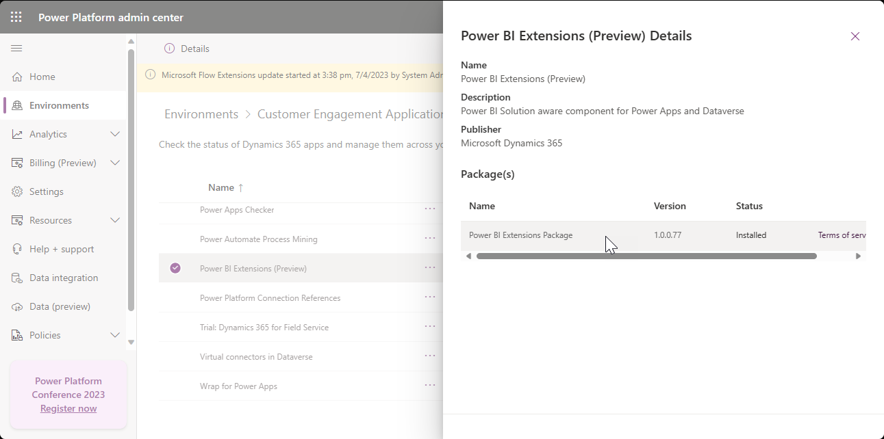

# Create Local Copies of the Solution and Source Data file

1. Download the example files from the source: <https://github.com/mscottsewell/ContosoBI> (From the “Code” menu choose “Download Zip”  
   Graphical user interface, text

   Description automatically generated
2. Once Downloaded - right click on the file, select ‘Properties’ and then check the ‘unblock’ option and ‘apply’ that change.  
   Graphical user interface, application

   Description automatically generated
3. Right click on the zip file and “extract” it to a temporary folder on your pc. – We’ll make a few changes before publishing it to your instance.
4. You should see these files in the “\Contoso - Sales - Current Release\Dataverse Data” folder:  
   A screenshot of a computer

   Description automatically generated

# Import Solution containing Power BI report and dashboard.

1. In the <https://make.powerapps.com/> import the Sales Analytics solution previously downloaded.  
   A screenshot of a computer

   Description automatically generated
2. Once the import of the solution is completed, click Publish All customizations  
   A screenshot of a computer

   Description automatically generated

# Set up Power BI Credentials and Report Refresh

1. Open the newly published solution and select the “**Power BI Report**” named “*Dynamics 365 Sales Demo – Excel*” – Then click “Open In Power BI  
   A screenshot of a computer

   Description automatically generated
2. Once Power BI opens – select the Workspace (named “Solutions […]” and click the ellipse (“…”) beside the Dataset and open “Settings”.  
   A screenshot of a computer

   Description automatically generated
3. You may need to set the “Data source credentials” – if so, just click on ‘Edit Credentials” then select “OAuth2” as the authentication method and enter your demo admin user/password  
   A screenshot of a computer

   Description automatically generated
4. Once that’s in place you can scroll a little further down the same list of settings to enable a refresh schedule –(to keep the dates in the report ‘current’)  
   A screenshot of a computer

   Description automatically generated  
   (Be sure to click ‘Apply’)
5. If you ever want to change which file is used for the report’s data, you can change the URL here in settings under Parameters.

# Adding the Power BI report to Dynamics

1. Open the PowerApp Maker Portal <https://make.powerapps.com/> (be sure your environment is selected) and go to the list of Apps – Select the app you want to add this report to and ‘Edit’  
   A screenshot of a computer

   Description automatically generated
2. Click “Add page” and then select “Dashboard” as the type of page you’re adding.  
   A screenshot of a computer

   Description automatically generated
3. Scroll down and choose “Sales Analytics” under Power BI dashboards to add this report to the list of reports in the “Dashboard” section in the app – If the ‘Show in navigation’ option is left selected, it will also add it to the navigation as a top level element.  
   A screenshot of a computer

   Description automatically generated
4. Save/Publish/Play to see your new dashboard in the App  
   A screenshot of a computer

   Description automatically generated